Software Engineering with Group Project

Testing Report

## Project : Web Browser

## Group Mentor: Dr. Noman Javed

## Group Members:

1. Badar Shahzad Khan,
2. Mohammad Hassan Iqbal Khan,
3. Naeem Rashid,
4. Ramzan Shahid Khan,
5. Shoaib khan,
6. Sana ullah khan.

**Project : Web Browser** **0**

**Group Mentor: Dr. Noman Javed** **0**

**Group Members:** **0**

**Testing Approach:** **1**

1. Test Cases for User Sign In 1

2. Test Cases for Signup: 3

3. Test cases for History: 4

4. Test case for Bookmarks: 6

5. Test cases for Downloads: 9

6. Test Case for New Tab: 10

7. Test cases for Multi tab: 11

8. Test Cases for Proxy Setting: 12

9. Test case for Save HTML page as PDF: 15

10. Test Case for Setting: 15

11. Test Cases for traversing within same tab: 17

12. Test Cases for Refresh: 19

13. Test case for Forward: 20

14. Test Case for Backward: 21

15. Test Case for Search Bar: 22

**References:** **24**

## Testing Approach:

Throughout the testing for this document, we did Black Box testing. Black Box Testing is the technique in which we focus only on the output generated against the given input and ignore the internal structure of the system including design, implementation. It only examines the functionality of the application. It is also usually known as functional testing.

### 1. Test Cases for User Sign In

First test case is to login on the application. Only authorized users can login by putting their username and password.

|  |  |  |  |
| --- | --- | --- | --- |
| **Step** | **Description** | **Expected Results** | **Status** |
| Made an account | Tried a login through this account | Successful login expected | Pass |
| Empty fields | Tried a login through at least one empty field | Should not sign-in and notify that fields are empty | Pass |
| Wrong try | Tried a valid user name but wrong password | Login will not be successful | Pass |
| Wrong try | Tried a wrong user name but valid password | Login will not be successful | Pass |

#### 

Sign-in Image:

In the below given picture, if user try to login and the required fields are empty then application is showing the error dialogue of empty fields.

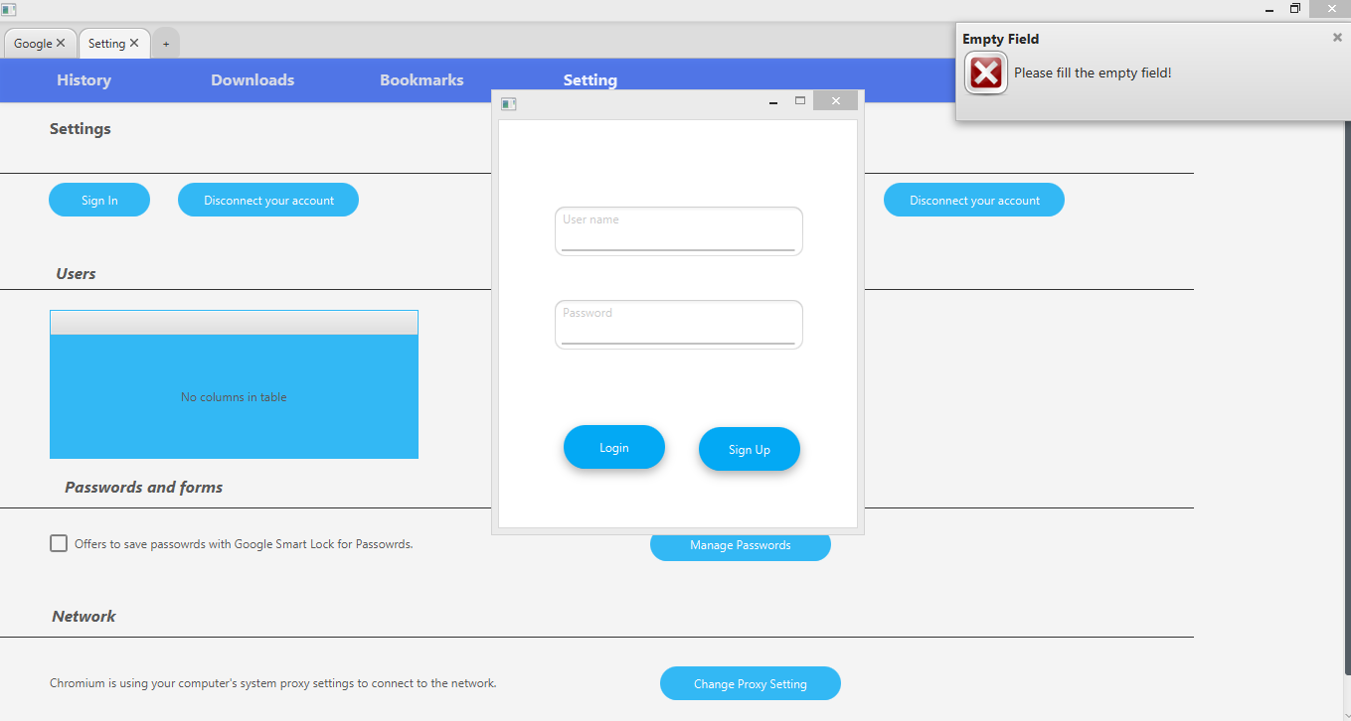

### 

### 2. Test Cases for Signup:

|  |  |  |  |
| --- | --- | --- | --- |
| **Step** | **Description** | **Expected Results** | **Status** |
| Empty fields | User tries to sign-up with empty fields | Application should notify that fields are empty | Pass |
| Invalid inputs | User tries to sign-up with invalid inputs | Application should notify that fields have invalid inputs | Pass |
| Cancel button | User clicks on cancel button after typing in fields | There should be no sign-up and sign-up window should be closed | Pass |
| Sign-up button | User clicks sign-up button after typing in the fields | There should be sign-up if the inputs are valid | Pass |

Sign-Up Image:

In the below given picture, if user try to sing-up and the required fields are empty then application is showing the error dialogue of empty fields.

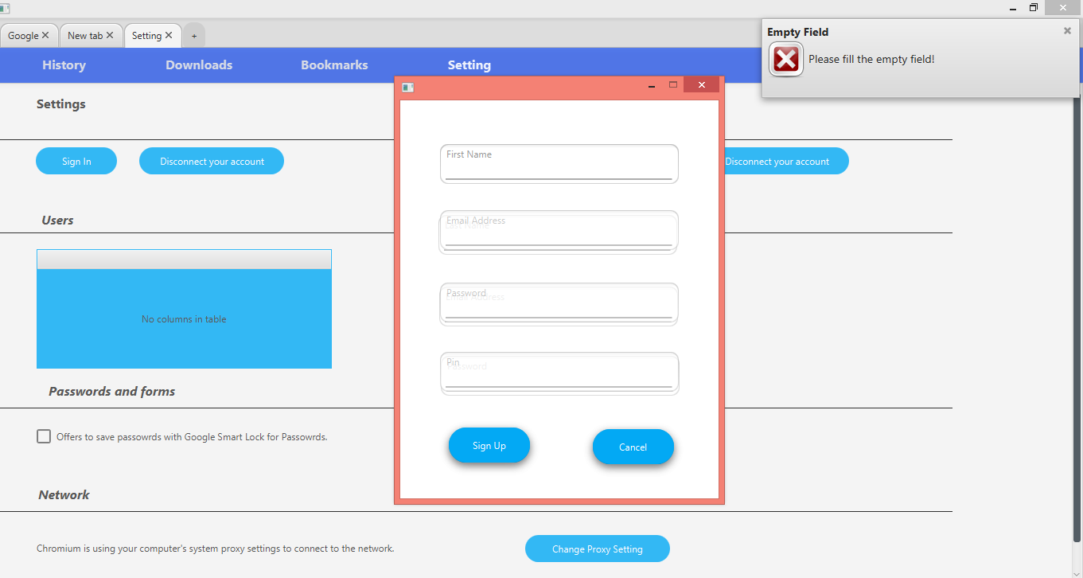

In the below given picture, if user try to enter wrong inputs, the application notifies for the wrong inputs.

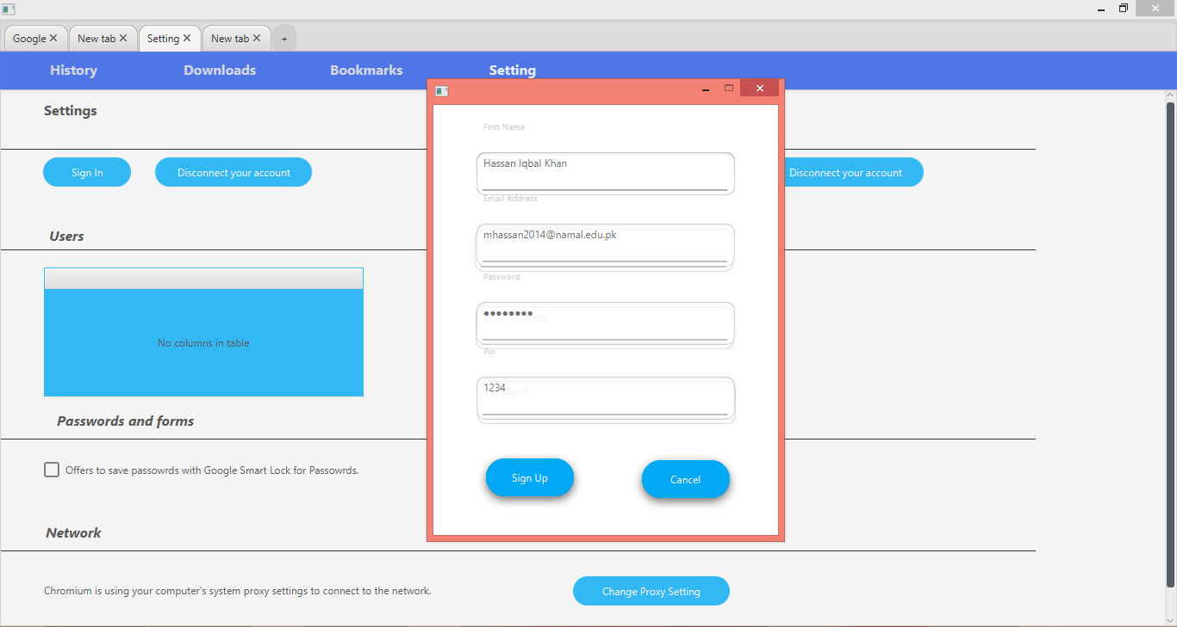

### 3. Test cases for History:

|  |  |  |  |
| --- | --- | --- | --- |
| **Step** | **Description** | **Expected Results** | **Status** |
| Searched new link | When user opened new link | Link, date and time added to the History table | Pass |
| Select Delete Button | When user select delete button | Application should show confirmation message for deleting the history. | Pass |
| Select Cancel Button | When user select cancel button | Application should not delete the history | Pass |
| Order History in Ascending/ Descending | When user try to see recently opened links at the start. | History table should show recently opened links at the top of the table. | Pass |

History Image:

In the below given picture history is shown, whenever user opens any link, that link is added to the history table with its time,date and title.

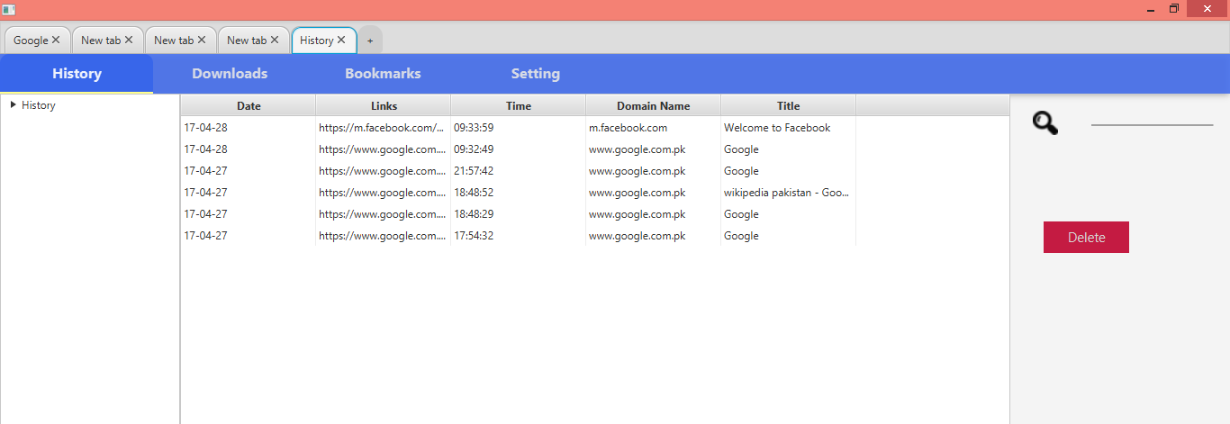

In the below given picture history is shown, whenever user try to delete history a confirmation message is displayed which ask user to delete history or not.

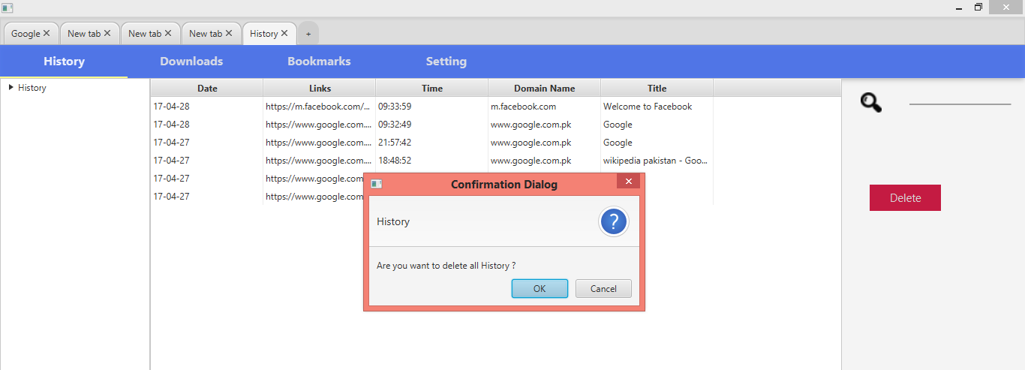

In the below given picture history is shown, whenever user try to delete history a confirmation message is displayed which ask user to delete history or not. If user clicked ok button the history is deleted and “history has been deleted” message is displayed.

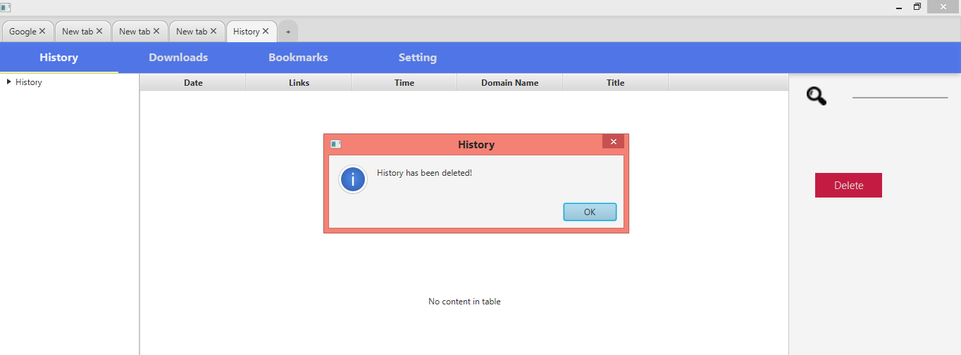

### 4. Test case for Bookmarks:

|  |  |  |  |
| --- | --- | --- | --- |
| **Step** | **Description** | **Expected Results** | **Status** |
| New link opened and Bookmarked button clicked | When user open new link and clicked bookmarks button. | Notification window should open and ask user to enter the title of the bookmarked link | Pass |
| New folder creation in bookmarks | When user open new link and clicked bookmarks button there is option to create new folder and store the link in that folder | New folder should be created and link should be stored in it | Pass |
| Save button clicked | When user click bookmark button and entered the title of the of the link and then clicked save button | Link should be added to the bookmarks table. | Pass |
| Cancel button clicked | When user open new link and clicked bookmarks button there is option to cancel this process | When cancel button is clicked there should be no change in bookmarks, it should remain as it was previously. | Pass |

Bookmarks Image:

In the below given picture, whenever user open any link and want to bookmark that page for future use, user will press bookmarks button and a popup will appear which will ask user for the folder to which this link will be saved along with its title.

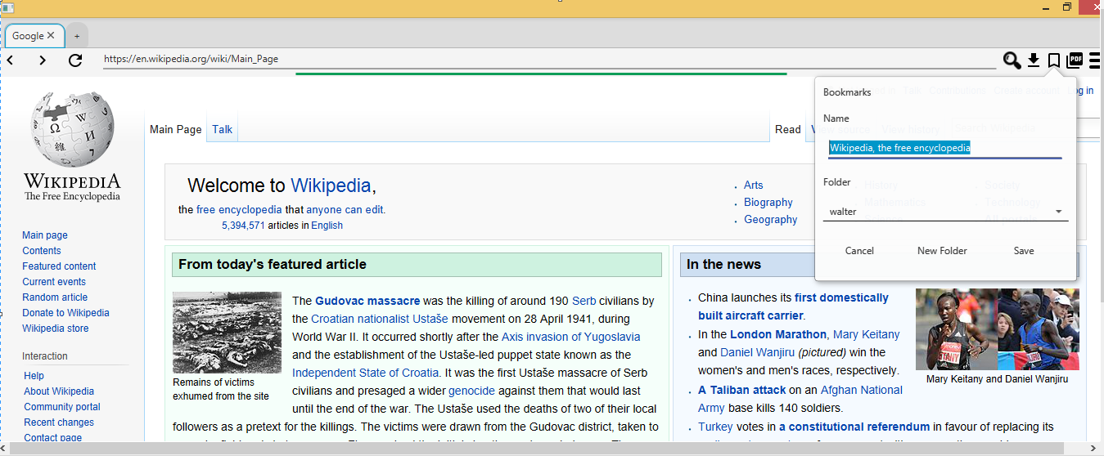

In the below given picture, if user want to create new folder for saving links, user will click new folder button and dialogue will appear which will ask user to enter the name of the folder to be created.

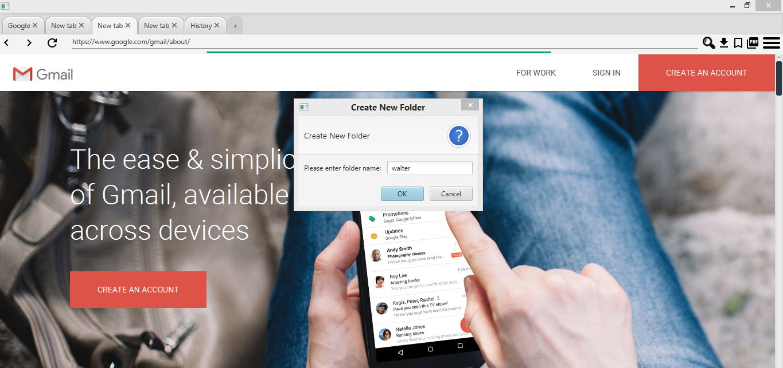

When user clicked bookmark button from the hamburger, a new tab will appear which contains all the links along with the time and date in their respective folders. The below given picture shows the links along with their folder names.

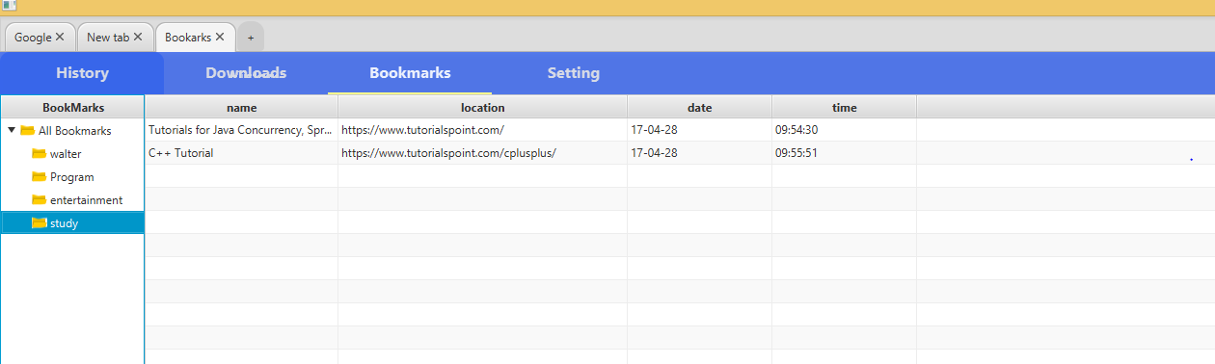

### 5. Test cases for Downloads:

|  |  |  |  |
| --- | --- | --- | --- |
| **Step** | **Description** | **Expected Results** | **Status** |
| Video, audio or any other document opened and clicked download button | When user tried to open any downloadable file | Application should start downloading the file and | Pass |
| Downloaded file saved | When user opened downloadable file and clicked download button. | Window should appear to ask for specific place where downloaded file will be saved. | Pass |

Downloads Image:

In the below given picture, whenever user open any PDF document link and want to download that document, user clicked download icon and application will start downloading PDF document and a confirmation message will be displayed to show that downloading has started.

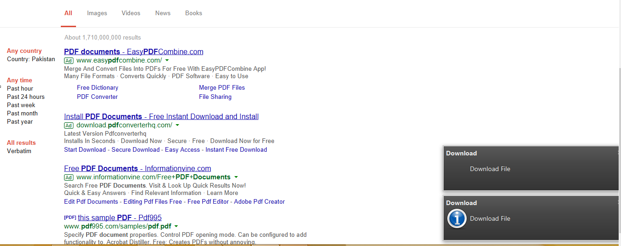

In the below given picture, whenever user open any video link and want to download that video, user clicked download icon and application will start downloading video file and a confirmation message will be displayed to show that downloading has started.

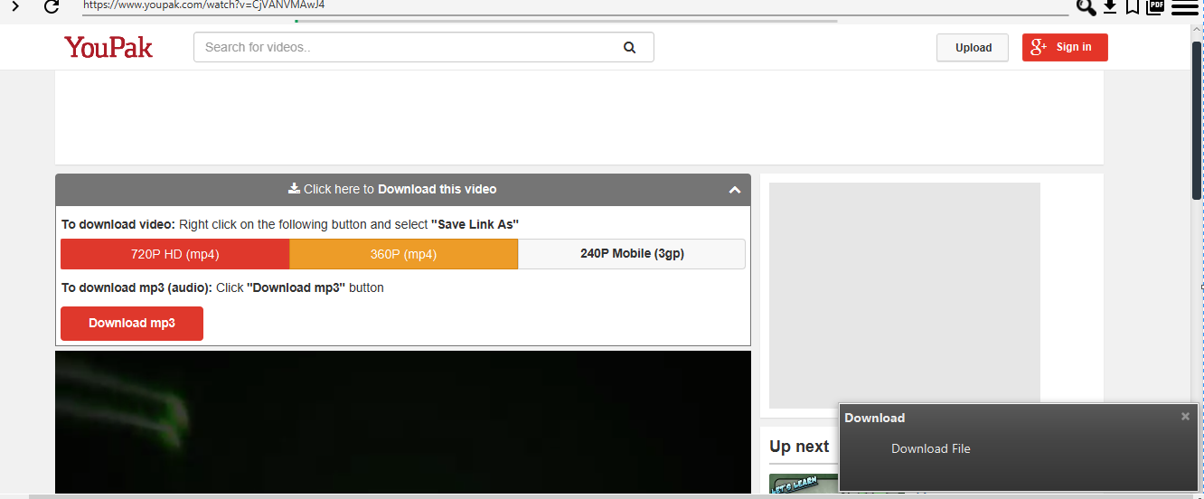

### 6. Test Case for New Tab:

|  |  |  |  |
| --- | --- | --- | --- |
| **Step** | **Description** | **Expected Results** | **Status** |
| New tab icon clicked | User opened browser and clicked new tab icon. | Browser should open a new tab and set that tab as the home page of Google Chrome | Pass |

New tab Image:

In the below given picture user has opened any tab and wants to open another tab, user will just click “+” button and a new tab will be opened successfully.

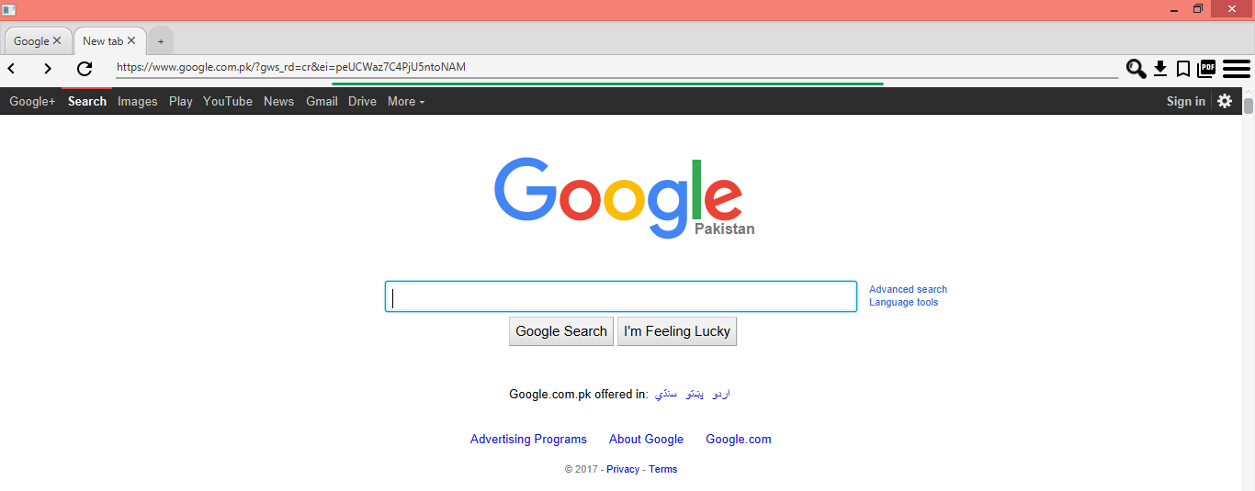

### 7. Test cases for Multi tab:

|  |  |  |  |
| --- | --- | --- | --- |
| **Step** | **Description** | **Expected Results** | **Status** |
| New tab icon clicked | User when clicked the new tab icon that is plus sign | New tab should be opened | Pass |
| Cross button clicked | User when clicked the cross button of the opened tab | Tab should be closed | Pass |
| Switching between different tabs | When different tabs are open, switching between tabs by clicking on them | Each tab should be opened when clicked | Pass |

Multi-tab Image:

In the below given picture user has opened many tab and wants to open another tab, user will just click “+” button and a new tab will be opened successfully. Thus the multi tabbing is working successfully.

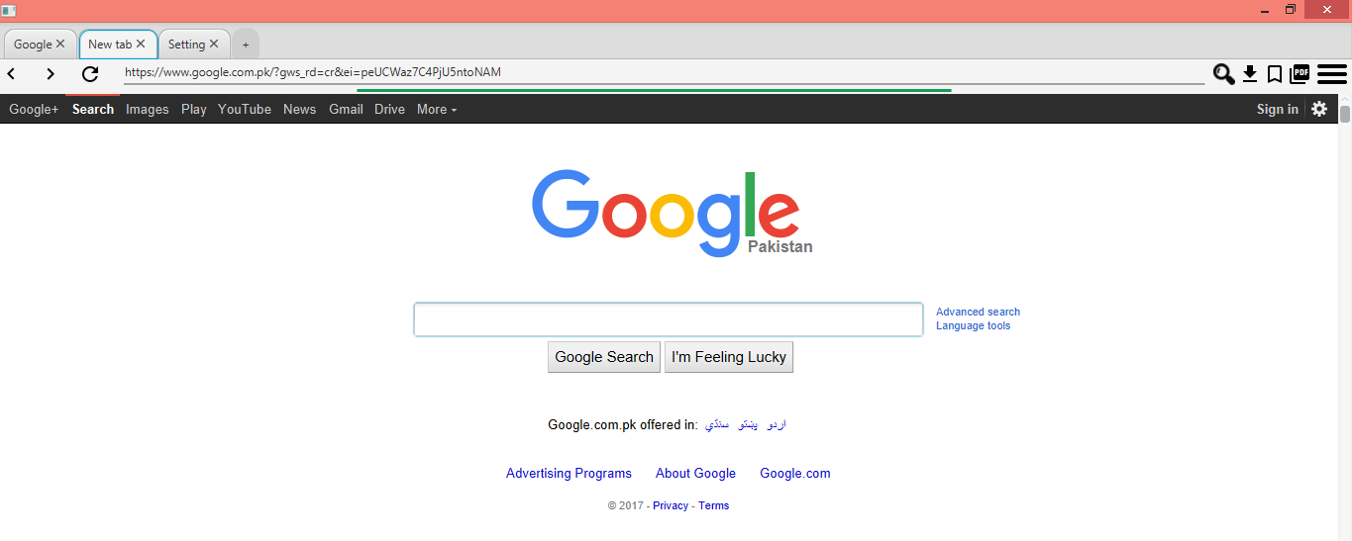

### 8. Test Cases for Proxy Setting:

|  |  |  |  |
| --- | --- | --- | --- |
| **Step** | **Description** | **Expected Results** | **Status** |
| No proxy | User open browser and start browsing without setting proxy. | Browser should be enabled to show the result if proxy is not needed. | Pass |
| System proxy setting | User opened proxy setting | Browser should set its proxy to the proxy same as system proxy | Pass |
| Manually added Proxy | User add proxy manually by typing | Proxy should be configured | Pass |
| Ok button Clicked | After selecting from above three options there is ok button to confirm your selection | Selection option should be performed | Pass |
| Cancel Button Clicked | After selecting from above three options there is cancel button to confirm your selection | Nothing should happen and proxy status will remain as it was before | Pass |

Proxy Setting Image:

In the below given picture, when user open setting tab and clicked change proxy setting button, a dialogue will be appeared. This dialogue will ask user to set the proxy of this application. If user will click the “No proxy” then the application will set no proxy.

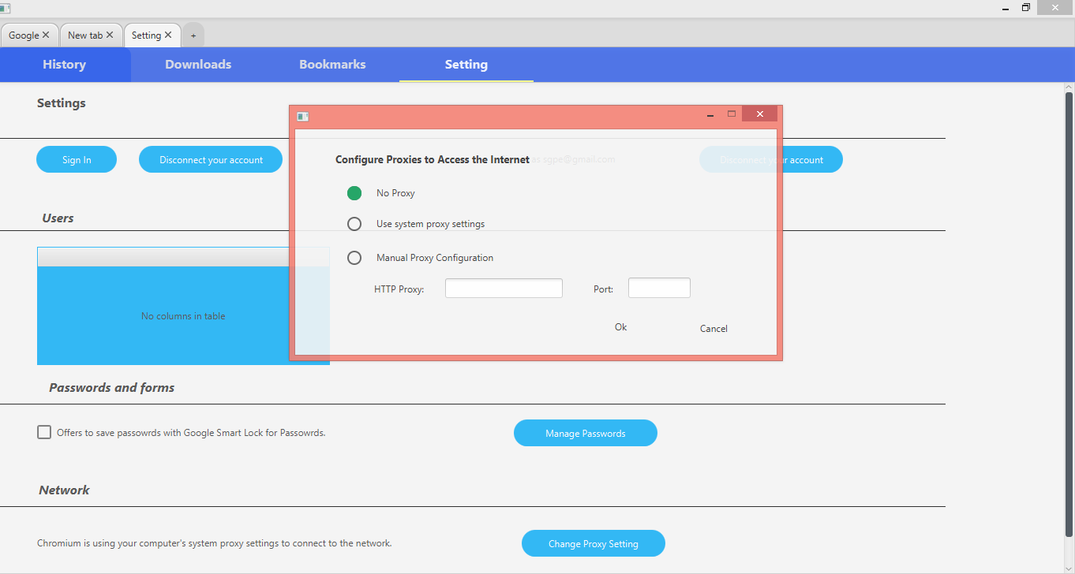

In the below given picture, when user open setting tab and clicked change proxy setting button, a dialogue will be appeared. This dialogue will ask user to set the proxy of this application. If user will click the “use system proxy setting” then the application will set application proxy to the system proxy.

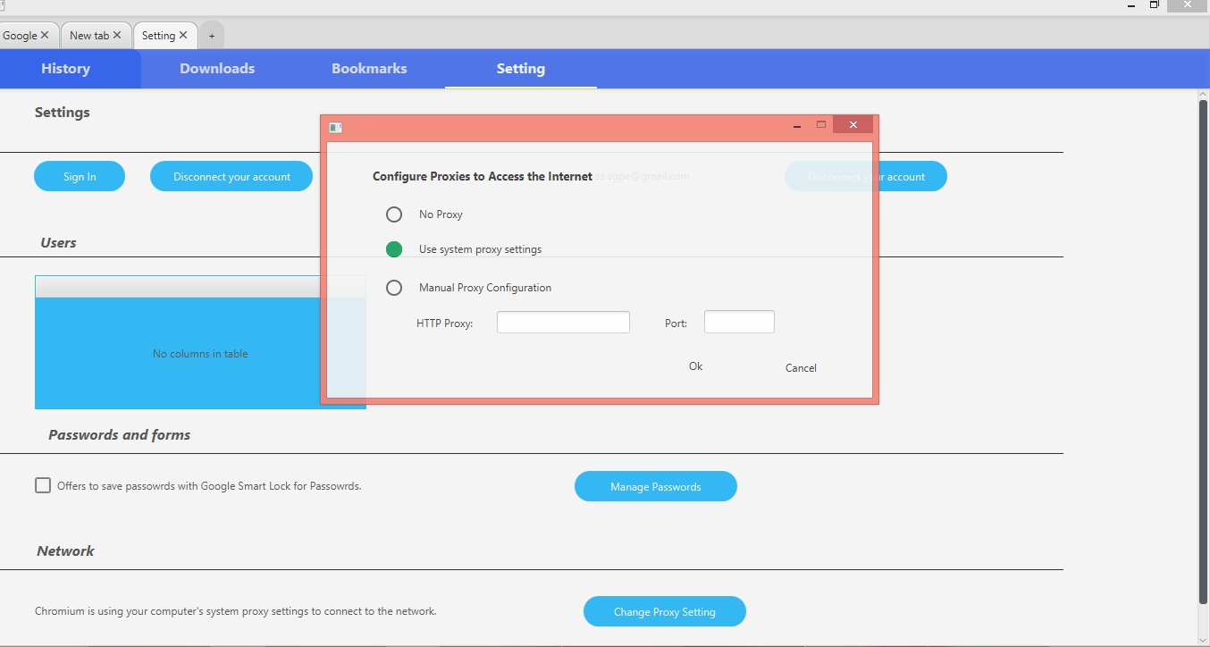

In the below given picture, when user open setting tab and clicked change proxy setting button, a dialogue will be appeared. This dialogue will ask user to set the proxy of this application. If user will click the “Manually proxy setting” then the application will ask user to enter the http proxy and port number and will click “Ok” button then application will set proxy manually.

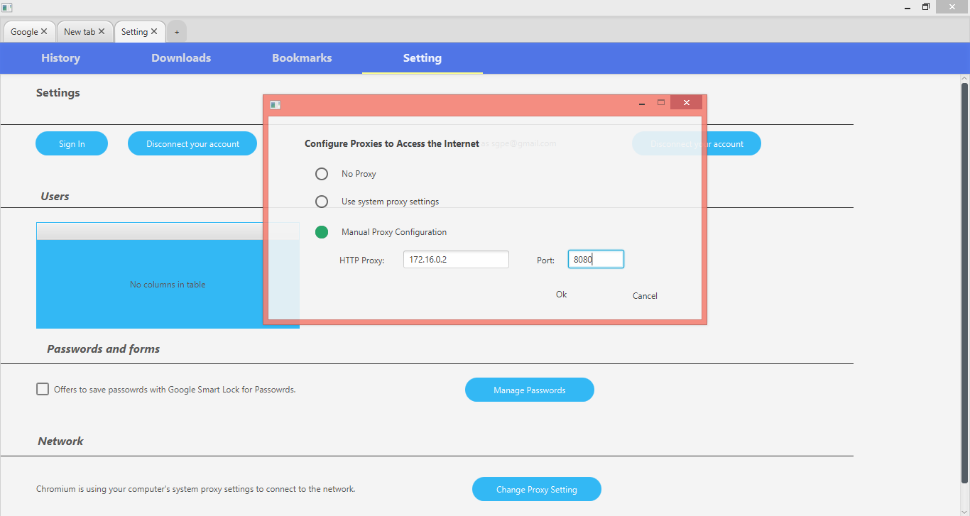

### 9. Test case for Save HTML page as PDF:

|  |  |  |  |
| --- | --- | --- | --- |
| **Step** | **Description** | **Expected Results** | **Status** |
| Any HTML page opened and PDF button clicked | When any html page is opened and user clicked pdf button | HTML page should be converted to PDF document | Pass |

HTML to PDF Image:

### 10. Test Case for Setting:

|  |  |  |  |
| --- | --- | --- | --- |
| **Step** | **Description** | **Expected Results** | **Status** |
| Sign-in Clicked | When sign-in button clicked | a pop up for sign-in. | Pass |
| Change proxy Setting clicked | When change proxy setting button clicked | a pop up for change proxy setting should appear | Pass |
| Traversing within same tab | When from setting, bookmarks, history or download options anyone is opened other options are also there in form of tabs | User can traverse between these tabs | Pass |

Setting Image:

In the below given picture, when user open setting window and clicked sign-in button then application should ask user to enter the username and password to login to the application.

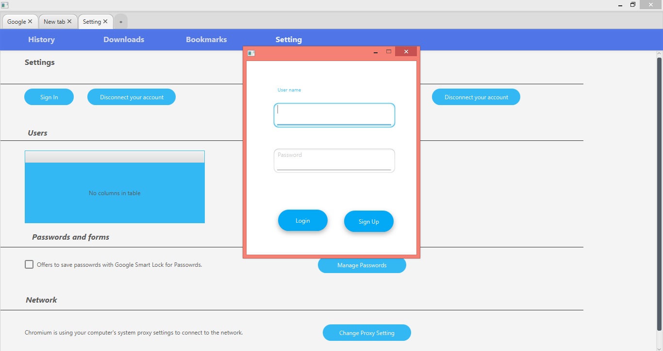

In the below given picture, when user open setting window and clicked change proxy setting button then application should ask user to enter the proxy manually or set system proxy for application to access internet



### 11. Test Cases for traversing within same tab:

|  |  |  |  |
| --- | --- | --- | --- |
| **Step** | **Description** | **Expected Results** | **Status** |
| History Clicked | When user clicked history button | Application should open history page and set tab name as “History”. | Pass |
| Bookmarked Clicked | When user is on same tab and clicked Bookmarks button | Application should open bookmarks page and set tab name as “Bookmarks”. | Pass |
| Setting Clicked | When user is on same window and clicked setting button | Application should open setting page and set tab name as “Setting”. | Pass |
| Downloads Clicked | When user is on same window and clicked downloads button | Application should open downloads page and set tab name as “Downloads”. | Pass |

#### 

Traversing Image:

When user clicked “History” button from hamburger, then application should show the history and user can also navigate between different pages i.e. Bookmarks, Downloads and Setting on the same page. Below picture shows the history page and user can navigate between different windows.

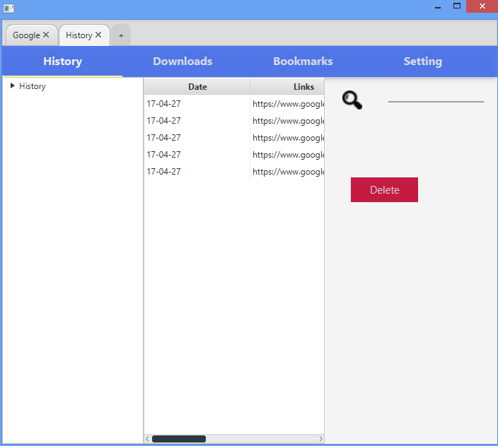

Now if user will click Downloads button on the same window, then application should take user to the downloads window and set tab name to “Downloads”.

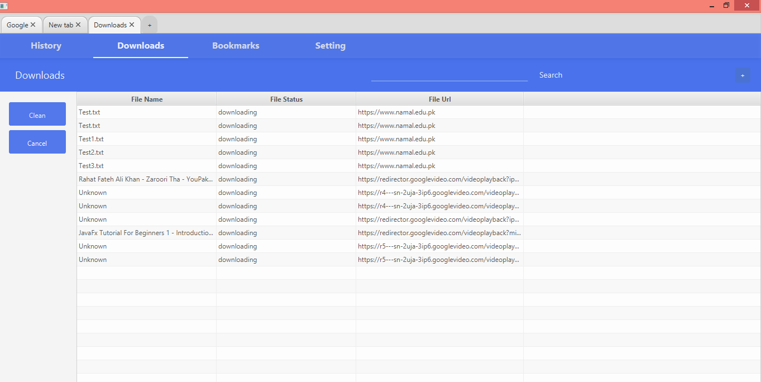

### 12. Test Cases for Refresh:

|  |  |  |  |
| --- | --- | --- | --- |
| **Step** | **Description** | **Expected Results** | **Status** |
| Refresh button clicked | When user has opened any page and clicked refresh button | Application should reload the same page | Pass |

Refresh Image:

In the picture given below, when user has opened any page and clicked reload or refresh icon then application should reload the same page.

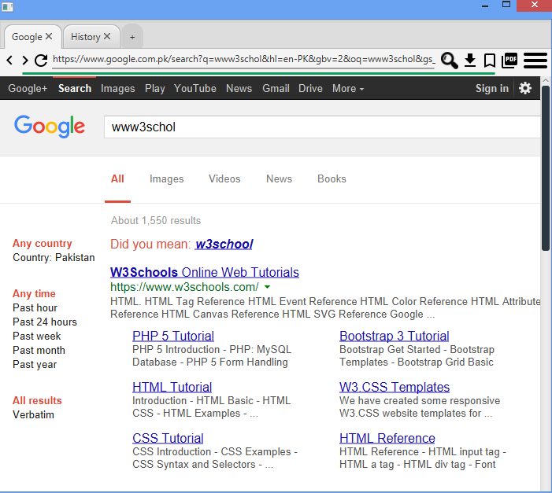

### 13. Test case for Forward:

|  |  |  |  |
| --- | --- | --- | --- |
| **Step** | **Description** | **Expected Results** | **Status** |
| Forward Button Clicked | When user has opened any page and clicked forward button | If any page is opened on the next page then Application should load the next page | Pass |

Forward Image:

In the picture given below, when user has opened any page and clicked forward icon and user has opened new link on same window then application should take user to next link on same window otherwise remain on same window.

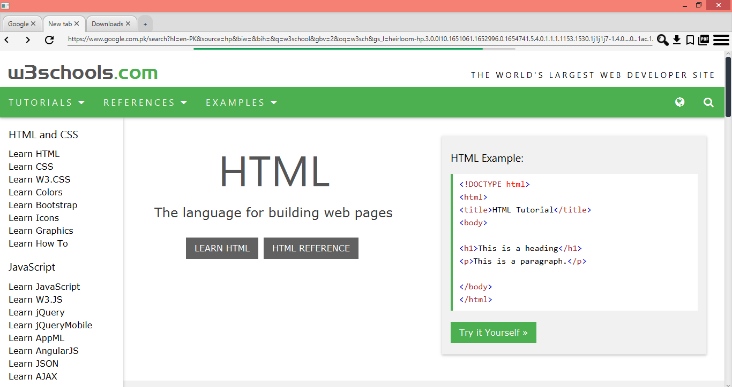

### 14. Test Case for Backward:

|  |  |  |  |
| --- | --- | --- | --- |
| **Step** | **Description** | **Expected Results** | **Status** |
| Backward button  clicked | When user has opened any page and clicked backward button | If any page is opened on the previous page then Application should load the previous page | Pass |

Backward Image:

In the picture given below, when user has opened any page and clicked backward icon and user has now moved to new link on same tab then application should take user to previous link on same tab.

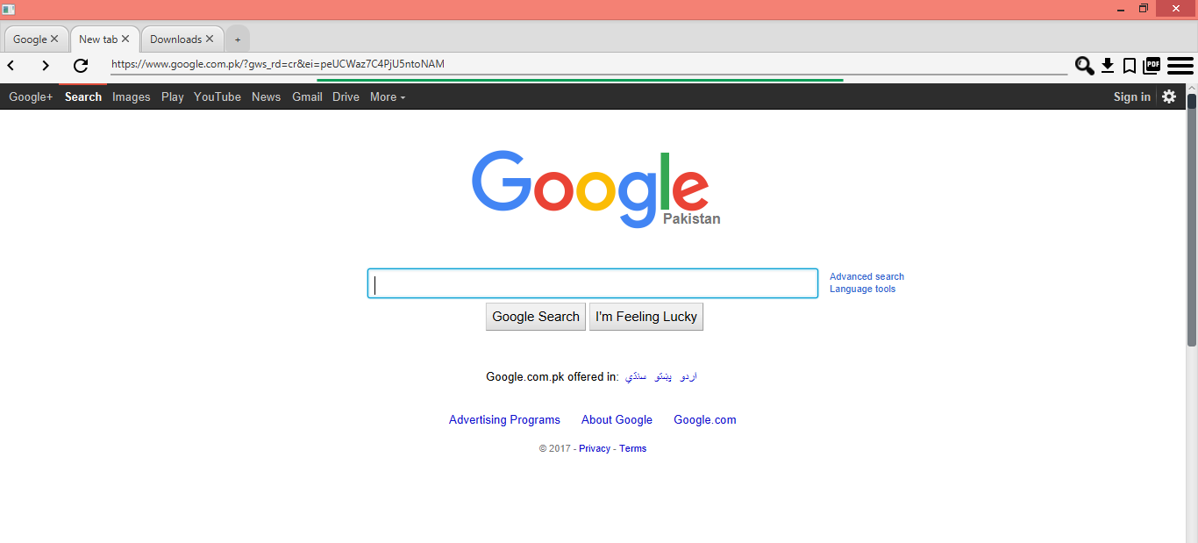

### 15. Test Case for Search Bar:

|  |  |  |  |
| --- | --- | --- | --- |
| **Step** | **Description** | **Expected Results** | **Status** |
| Valid url entered and searched | When valid url is entered in a search bar and searched button clicked | Application should show the result of the valid URL | Pass |
| Invalid url entered and searched | When invalid url is entered and searched button clicked | Application should not show any result of the invalid URL | Pass |

Search Bar image:

The below given picture shows that if user entered valid URL and clicked searched icon then application should show the result of the entered URL.

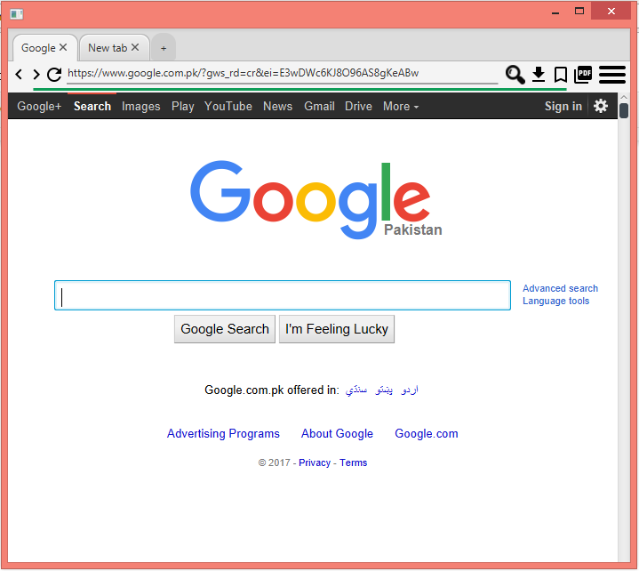

THe below given picture shows that if invalid URL is entered and searched icon clicked then application should not show any result of the invalid URL.

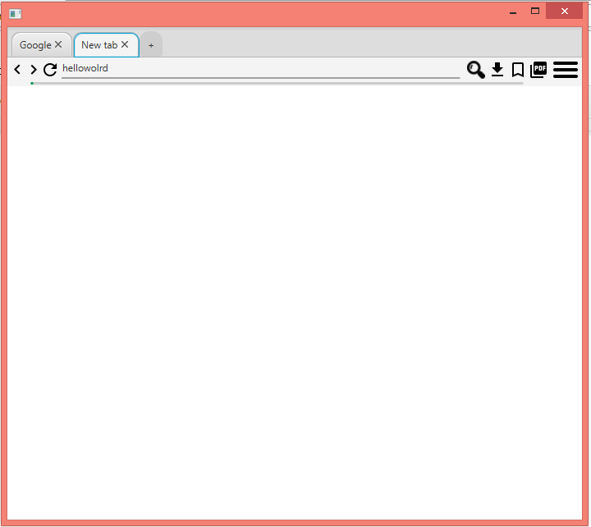

## 

## 

# References

### **JUNIT OVERVIEW**

In-text: (www.tutorialspoint.com, 2017)

Your Bibliography: www.tutorialspoint.com. (2017). *JUnit Overview*. [online] Available at: https://www.tutorialspoint.com/junit/junit_overview.htm [Accessed 15 Apr. 2017].